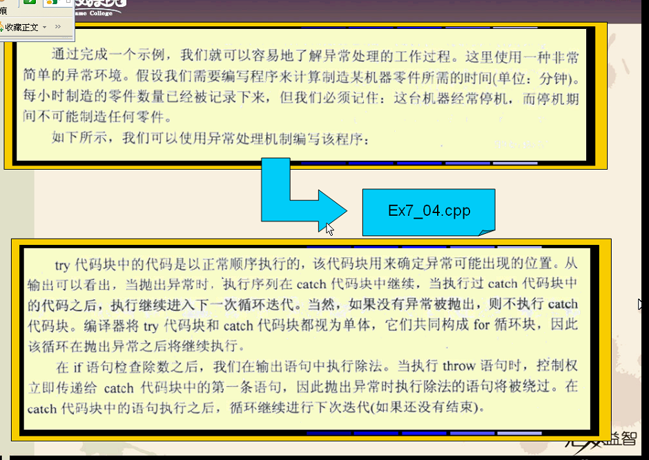

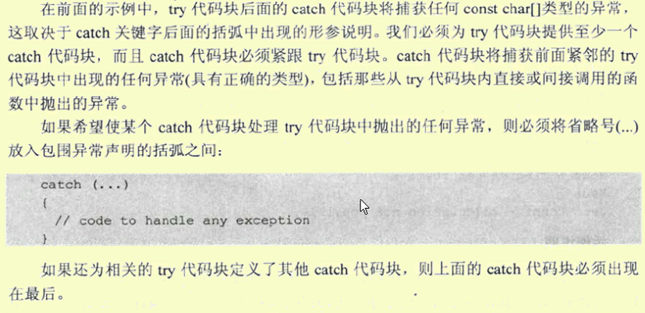
Try后面必跟cacatch 以捕获try 抛出的异常
int main(void)
{
int height = 0;
const double inchesToMeters = 0.0254;
char ch = 'y';

try // Outer try block
{
while(ch == 'y'||ch =='Y')
{
cout << "Enter a height in inches: ";
cin >> height; // Read the height to be converted

try // Defines try block in which
{ // exceptions may be thrown
if(height > 100) //抛出异常
throw "Height exceeds maximum"; // Exception thrown
if(height < 9) //此异常将往向抛 跟第一个try
throw height; //因为抛的是一个整数 下面的try将//不处理 面往向抛

cout << static_cast<double>(height)*inchesToMeters
<< " meters"
<< endl;

}
catch(const char aMessage[]) // 捕获异常
{ // catches exceptions of type
cout << aMessage << endl; // const char[]
}
cout << "Do you want to continue(y or n)?"; >100 是能执行这里的 <9不能以往向抛
cin >> ch;
}
}
catch(int badHeight)
{
cout << badHeight << " inches is below minimum" << endl;
}
return 0;
}
- 根据错误的类型 来捕获异常 第一个是字符串 第二个是整型 是不同的

========================================================
int main(void)
{
int a[6] = {1, 2, 0, 4, 0, 6};

for(int i = 0; i < static_cast<int>(sizeof(a)/sizeof(a[0])); i++)
try
{
cout<<"how:"<<i+1<<endl;

if(a[i] == 0)
throw " error !";

cout<<"a[] = "<<a[i]<<endl;
}
catch(const char aMessage[])
{
cout<<endl
<<aMessage
<<endl;
}

return 0;
}
= = = = = = = = = = = = = = = = = = = = = = = = =
内存分配异常
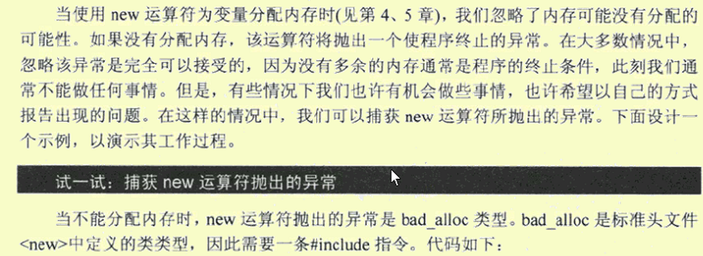

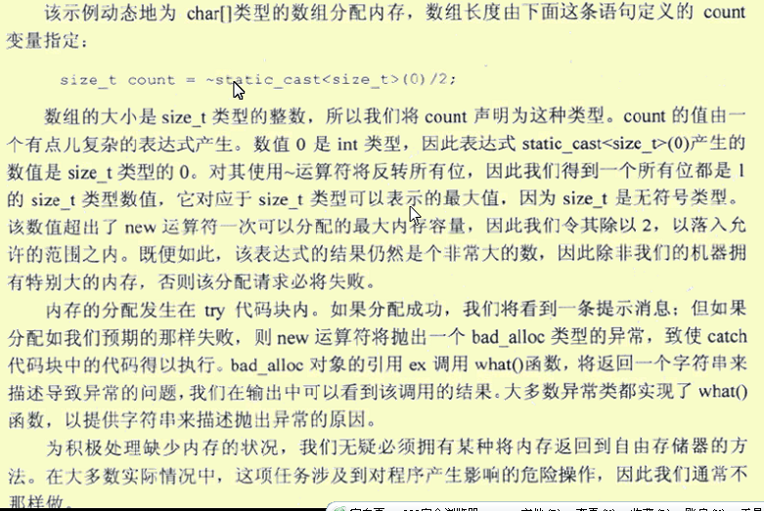
int main( )
{
char* pdata = 0;
size_t count = ~static_cast<size_t>(0)/2;
try
{
pdata = new char[count];
cout << "Memory allocated." << endl;
}
catch(bad_alloc &ex)
{
cout << "Memory allocation failed." << endl
<< "The information from the exception object is: "
<< ex.what() << endl;
}
delete[] pdata; // 万一分配成功
return 0;
}

